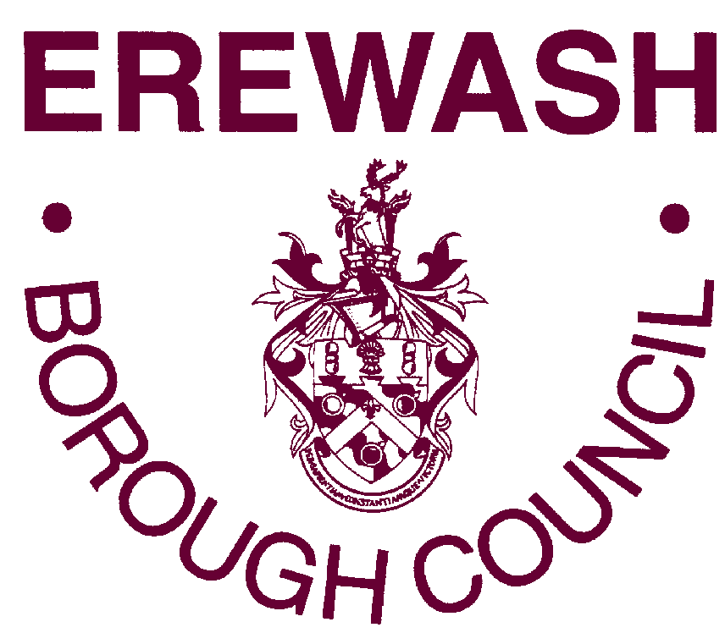

APPLICATION FOR TEMPORARY ROAD CLOSURE UNDER SECTION 21 OF THE

TOWN POLICE CLAUSES ACT 1847

1 | Event:
2 | Applicant Name:
3 | Name and correspondence address of Organisation:
4 | Location of Event:
5 | Date(s) of Event:
6 | Time(s) of Event:
7 | Detail of route  – please specify:
8 | Is a diversion route required?  If YES please detail
9 | Is a bus route affected?  If YES please detail
10 | How many people are expected to attend?
11 | How many Marshalls will be provided and where will they be positioned? Please detail on your enclosed route map
12 | Has signage been arranged?

13 | Emergency contact number(s) during event:  Please be aware these contact details will be passed on to the emergency services
If your event takes place on a regular or annual basis (including civic events) and you agree to have your application and details kept for future road closure events use, please tick (or mark) the box. For more information explaining how we protect and use your information please see our privacy policy at www.erewash.gov.uk/privacy

Signature: _____________________________________

Print Name: _____________________________________ Date: ____________

Please ensure you have enclosed the following with your application:

 | Enclosed | Notes/Comments
Detailed map of route

Map of diversion route (if required)

Copy of public liability insurance to indemnify the Borough Council & the County Council. To the value of £5 million for any one accident
Copy of comprehensive risk assessment
Details of diversion signage if required

Please return this form to: Democratic Services, Erewash Borough Council, Town Hall
Ilkeston, Derbyshire DE7 5RP

Or email to: democratic@erewash.gov.uk

Please see details of charges for temporary road closures overleaf.

Payment for your closure can be made by either:

- telephoning the contact centre 0115 9072244 stating you wish to pay for a road closure, or
- make an electronic payment using these details: Lloyds Bank, sort code 30-96-18, account number 01226906 quoting the organisation or the organiser’s name and the reference ‘road closure’

We will start to progress with your road closure and will complete the process on confirmation of receipt of charge.

Erewash Borough Council temporary road closures charging bands

Band 1 | Local community events run by volunteers or EBC events  - Council events such as charter fair, Christmas lights switch on events and Festival of Lights.  - One off civic events such as Beating Retreat.  - Remembrance Sunday closures  - One off royal events such as street parties for jubilees  - Mercian freedom march or welcome home marches | Free
Band 2 | Regular local club challenge or community style events or arranged by parish councils  - Parish Council Christmas lights road closures  - Well dressings  - Ilkeston Cycle Club – boxing day hill climb  - Stanley Village Gala  - Long Eaton Carnival  - Breaston May day  - Little Eaton Carnival | £50.00
Band 3 | Sponsored events or events which have a participation fee  - Annual marathon style events which include entry fees  - Chestnut Fair – Mellors Group  - Wilne 10k  - Erewash Triathlon  - Ilkeston Heritage and Classic Vehicle Show  - Glow Music and Art festival | £150.00

