**Town, Local, and Village Centre Health Checks April 2025**

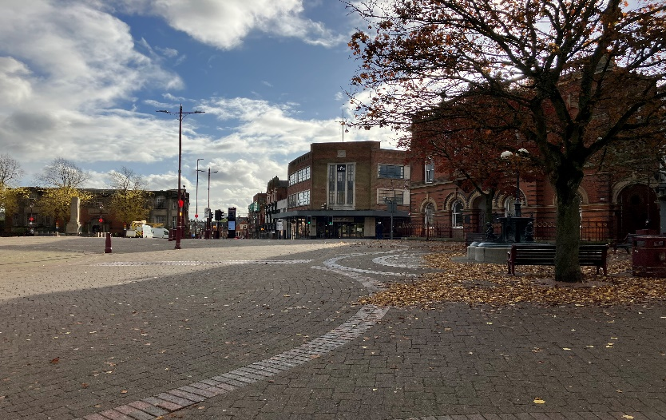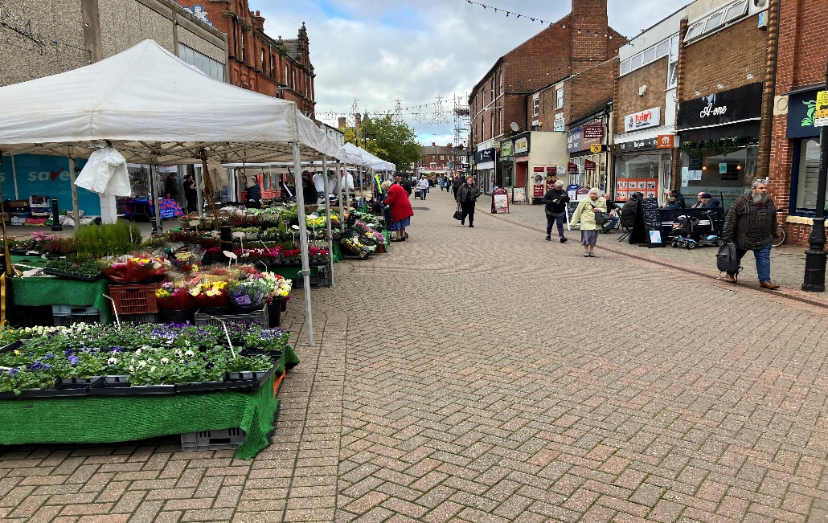

Table of Contents

**Introduction3**

**Ilkeston Town Centre4**

**Long Eaton Town Centre9**

**Borrowash Local Centre14**

**Sandiacre Local Centre15**

**Breaston Village Centre16**

**Draycott Village Centre17**

**Little Eaton Village Centre18**

**West Hallam Village Centre19**

**Appendix20**

2006 Data20

Annotated Boundary Maps21

# Introduction

Since 2018, Erewash Borough Council has produced an annual health check document regarding its two town centres; Long Eaton and Ilkeston, and its two local centres; Borrowash and Sandiacre. Since January 2023 four village centres have been included, in keeping with the draft Local Plan produced by Erewash Borough Council in 2022. These centres are: Breaston, Draycott, Little Eaton, and West Hallam.

These reports help provide the Council with information on planning use class, business category, business type, first/second floor use, and vacancy rates. Regular, 6 monthly, updates help to ensure effective monitoring of the Borough’s centres and reveal any patterns of change. The information in this document is based on the latest monitoring conducted during April 2025.

The Council is now able to compare this report’s data with Oct 2018 –October 2024’s data for vacancy rates. Since October 2024 Long Eaton has seen an increased vacancy rate in both its Primary Shopping Area (PSA) and it’s wider Town Centre. Breaston has also seen an increase in vacancy. Vacancy has declined in Sandiacre, Draycott, and in Ilkeston’s Town Centre. Vacancy in Ilkeston’s PSA has not changed, and the vacancy rate in Little Eaton and West Hallam has also remained constant.

The reports for both Town Centres show their PSA and whole area vacancy rates between January 2018 and October 2024. An additional comparison with the 2006 WYG Retail Needs Study Goad Centre Report can be found in the appendix. This is followed by data on the primary use category of ground, first, and second floor units. A 2018-2024 historical data comparison is also provided for ground floor units. Again the 2006 WYG Study can provide further comparison. Finally, there is a detailed breakdown of the business types within six Use Categories (Comparison Retail, Leisure Service, Other Commercial, Retail Service, Financial and Business Services, Convenience Retail. Other non-commercial is not included as the category is small and rarely contains more than one of each business type while residential and vacant are not included as they do not contain any business types).

The reports for the Local and Village Centres show vacancy rates between Jan 2018-Apr 25 for the Local Centres and between Jan 2023-Apr 25 for the village centres. This is followed by the ground and first floor use category data. Historical use category data is not available for comparison, second floor usage has been excluded as it is rare, and most use categories are not large enough to justify business type breakdowns.

The 2006 WYG Retail Needs Study Goad Centre Report and annotated boundary maps for the Town and Local Centres showing the use category of each unit can be found in the appendix.

# A building with a flag on it Description automatically generatedUpper Bath Street in October 2023 viewed from the elevated graveyard of St. Mary's Church.Ilkeston Town Centre



Upper Bath Street in October 2023

St Mary’s Church in April 2024

Market Place in October 2023

**Primary Shopping Area (PSA) Ground Floor Vacancy Rate**

Town Centre Ground Floor Vacancy Rate (Including PSA)

|  |  |  |
| --- | --- | --- |
| Use Category | Number of Units | % of Units |
| Residential | 13 | 4.50 |
| Financial & Business Services | 23 | 7.96 |
| Retail Service | 65 | 22.49 |
| Leisure Service | 56 | 19.38 |
| Convenience Retail | 21 | 7.27 |
| Comparison Retail | 57 | 19.72 |
| Other commercial | 8 | 2.77 |
| Other non-commercial | 7 | 2.42 |
| Unknown | 0 | 0.00 |
| Vacant | 39 | 13.49 |
| Total | 289 | 100.00 |

|  |  |  |
| --- | --- | --- |
| Use Category | Number of Units | % of Units |
| Residential | 108 | 41.86 |
| Financial & Business Services | 20 | 7.75 |
| Retail Service | 15 | 5.81 |
| Leisure Service | 12 | 4.65 |
| Convenience Retail | 7 | 2.71 |
| Comparison Retail | 17 | 6.59 |
| Other commercial | 3 | 1.16 |
| Other non-commercial | 7 | 2.71 |
| Unknown | 37 | 14.34 |
| Vacant | 32 | 12.40 |
| Total | 258 | 100.00 |

|  |  |  |
| --- | --- | --- |
| Use Category | Number of Units | % of Units |
| Residential | 79 | 56.03 |
| Financial & Business Services | 5 | 3.55 |
| Retail Service | 6 | 4.26 |
| Leisure Service | 0 | 0.00 |
| Convenience Retail | 3 | 2.13 |
| Comparison Retail | 9 | 6.38 |
| Other commercial | 1 | 0.71 |
| Other non-commercial | 2 | 1.42 |
| Unknown | 17 | 12.06 |
| Vacant | 19 | 13.48 |
| Total | 141 | 100.00 |

**Ilkeston Ground Floor Primary Business Type by Category**

# Long Eaton Town Centre

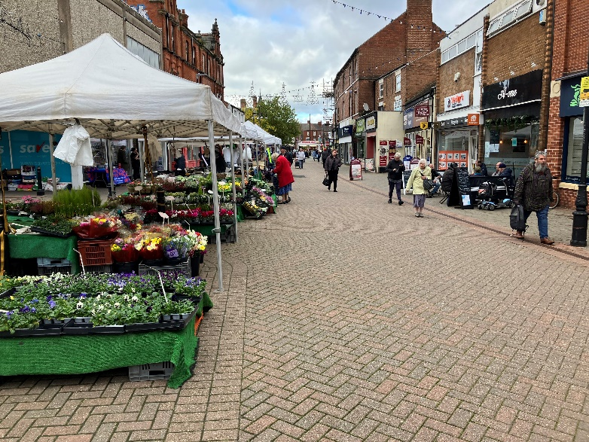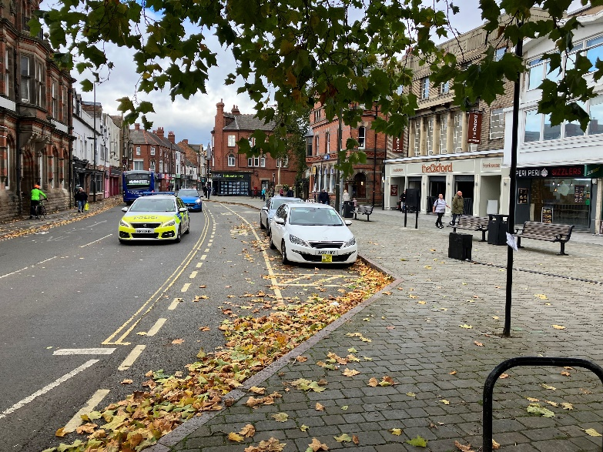

The Market Place in October 2023

High Street in October 2023

**Primary Shopping Area (PSA) Ground Floor Vacancy Rate**

Town Centre Ground Floor Vacancy Rate (Including PSA)

|  |  |  |
| --- | --- | --- |
| Use Category | Number of Units | % of Units |
| Residential | 20 | 8.03 |
| Financial & Business Services | 31 | 12.45 |
| Retail Service | 40 | 16.06 |
| Leisure Service | 45 | 18.07 |
| Convenience Retail | 19 | 7.63 |
| Comparison Retail | 49 | 19.68 |
| Other commercial | 12 | 4.82 |
| Other non-commercial | 4 | 1.61 |
| Unknown | 0 | 0.00 |
| Vacant | 29 | 11.65 |
| Total | 249 | 100.00 |

|  |  |  |
| --- | --- | --- |
| Use Category | Number of Units | % of Units |
| Residential | 80 | 37.38 |
| Financial & Business Services | 22 | 10.28 |
| Retail Service | 14 | 6.54 |
| Leisure Service | 12 | 5.61 |
| Convenience Retail | 8 | 3.74 |
| Comparison Retail | 22 | 10.28 |
| Other commercial | 14 | 6.54 |
| Other non-commercial | 0 | 0.00 |
| Unknown | 29 | 13.55 |
| Vacant | 13 | 6.07 |
| Total | 214 | 100.00 |

|  |  |  |
| --- | --- | --- |
| Use Category | Number of Units | % of Units |
| Residential | 41 | 64.06 |
| Financial & Business Services | 1 | 1.56 |
| Retail Service | 2 | 3.13 |
| Leisure Service | 0 | 0.00 |
| Convenience Retail | 0 | 0.00 |
| Comparison Retail | 6 | 9.38 |
| Other commercial | 4 | 6.25 |
| Other non-commercial | 0 | 0.00 |
| Unknown | 7 | 10.94 |
| Vacant | 3 | 4.69 |
| Total | 64 | 100.00 |

**Long Eaton Ground Floor Primary Business Type by Category**

# Borrowash Local Centre

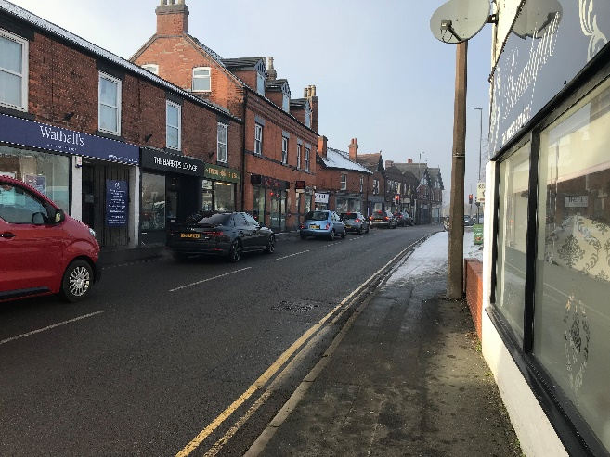

**Borrowash Ground Floor Primary Use Category**

|  |  |  |
| --- | --- | --- |
| Use Category | Number of Units | % of Units |
| Residential | 1 | 2.63 |
| Financial & Business Services | 1 | 2.63 |
| Retail Service | 11 | 28.95 |
| Leisure Service | 8 | 21.05 |
| Convenience Retail | 4 | 10.53 |
| Comparison Retail | 6 | 15.79 |
| Other commercial | 2 | 5.26 |
| Other non-commercial | 2 | 5.26 |
| Unknown | 0 | 0.00 |
| Vacant | 3 | 7.89 |
| Total | 38 | 100.00 |

**Borrowash Local Centre Ground Floor Vacancy Rate**

Nottingham Road in January 2023

**Borrowash First Floor Primary Use Category**

|  |  |  |
| --- | --- | --- |
| Use Category | Number of Units | % of Units |
| Residential | 20 | 64.52 |
| Financial & Business Services | 1 | 3.23 |
| Retail Service | 1 | 3.23 |
| Leisure Service | 2 | 6.45 |
| Convenience Retail | 0 | 0.00 |
| Comparison Retail | 3 | 9.68 |
| Other commercial | 0 | 0.00 |
| Other non-commercial | 0 | 0.00 |
| Unknown | 2 | 6.45 |
| Vacant | 2 | 6.45 |
| Total | 31 | 100.00 |

# Sandiacre Local Centre

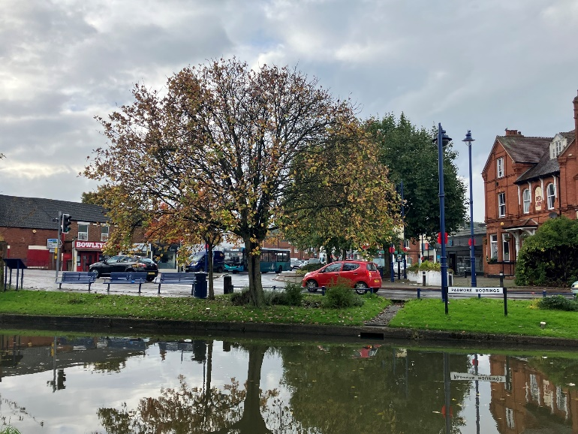

The view over the canal in October 2023

**Sandiacre Ground Floor Primary Use Category**

|  |  |  |
| --- | --- | --- |
| Use Category | Number of Units | % of Units |
| Residential | 16 | 19.05 |
| Financial & Business Services | 1 | 1.19 |
| Retail Service | 18 | 21.43 |
| Leisure Service | 17 | 20.24 |
| Convenience Retail | 6 | 7.14 |
| Comparison Retail | 12 | 14.29 |
| Other commercial | 5 | 5.95 |
| Other non-commercial | 0 | 0.00 |
| Unknown | 0 | 0.00 |
| Vacant | 9 | 10.71 |
| Total | 84 | 100.00 |

**Sandiacre Local Centre Ground Floor Vacancy Rate**

**Sandiacre First Floor Primary Use Category**

|  |  |  |
| --- | --- | --- |
| Use Category | Number of Units | % of Units |
| Residential | 44 | 63.77 |
| Financial & Business Services | 1 | 1.45 |
| Retail Service | 4 | 5.80 |
| Leisure Service | 2 | 2.90 |
| Convenience Retail | 0 | 0.00 |
| Comparison Retail | 1 | 1.45 |
| Other commercial | 1 | 1.45 |
| Other non-commercial | 0 | 0.00 |
| Unknown | 8 | 11.59 |
| Vacant | 8 | 11.59 |
| Total | 69 | 100.00 |

# Breaston Village Centre

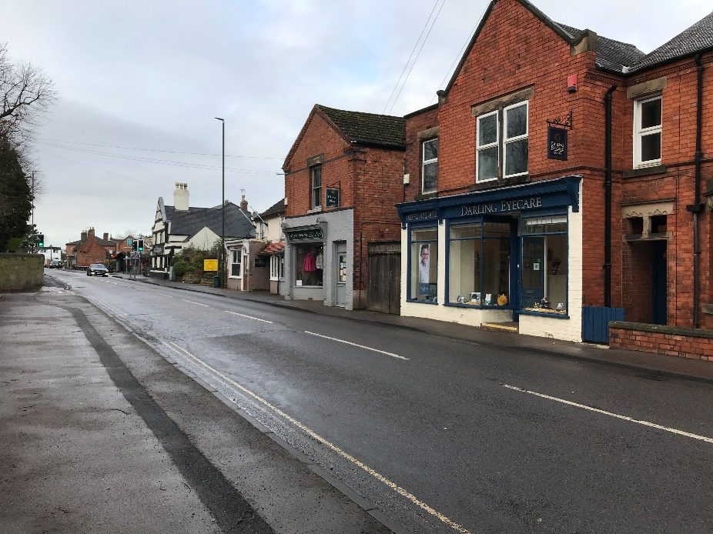

**Breaston Ground Floor Primary Use Category**

|  |  |  |
| --- | --- | --- |
| Use Category | Number of Units | % of Units |
| Residential | 14 | 31.11 |
| Financial & Business Services | 1 | 2.22 |
| Retail Service | 8 | 17.78 |
| Leisure Service | 7 | 15.56 |
| Convenience Retail | 3 | 6.67 |
| Comparison Retail | 2 | 4.44 |
| Other commercial | 2 | 4.44 |
| Other non-commercial | 3 | 6.67 |
| Unknown | 0 | 0.00 |
| Vacant | 5 | 11.11 |
| Total | 45 | 100.00 |

**Breaston Village Centre Ground Floor Vacancy Rate**

Main Street in January 2023

**Breaston First Floor Primary Use Category**

|  |  |  |
| --- | --- | --- |
| Use Category | Number of Units | % of Units |
| Residential | 29 | 76.32 |
| Financial & Business Services | 0 | 0.00 |
| Retail Service | 1 | 2.63 |
| Leisure Service | 1 | 2.63 |
| Convenience Retail | 0 | 0.00 |
| Comparison Retail | 0 | 0.00 |
| Other commercial | 1 | 2.63 |
| Other non-commercial | 0 | 0.00 |
| Unknown | 4 | 10.53 |
| Vacant | 2 | 5.26 |
| Total | 38 | 100.00 |

# The view in January 2023 from Station Road looking down towards Victoria Mill.Draycott Village Centre

**Draycott Ground Floor Primary Use Category**

|  |  |  |
| --- | --- | --- |
| Use Category | Number of Units | % of Units |
| Residential | 48 | 53.93 |
| Financial & Business Services | 1 | 1.12 |
| Retail Service | 11 | 12.36 |
| Leisure Service | 11 | 12.36 |
| Convenience Retail | 5 | 5.62 |
| Comparison Retail | 5 | 5.62 |
| Other commercial | 3 | 3.37 |
| Other non-commercial | 2 | 2.25 |
| Unknown | 0 | 0.00 |
| Vacant | 3 | 3.37 |
| Total | 89 | 100.00 |

**Draycott Village Centre Ground Floor Vacancy Rate**

Victoria Road in January 2023

**Draycott First Floor Primary Use Category**

|  |  |  |
| --- | --- | --- |
| Use Category | Number of Units | % of Units |
| Residential | 64 | 81.01 |
| Financial & Business Services | 0 | 0.00 |
| Retail Service | 0 | 0.00 |
| Leisure Service | 4 | 5.06 |
| Convenience Retail | 0 | 0.00 |
| Comparison Retail | 1 | 1.27 |
| Other commercial | 3 | 3.80 |
| Other non-commercial | 0 | 0.00 |
| Unknown | 6 | 7.59 |
| Vacant | 1 | 1.27 |
| Total | 79 | 100.00 |

# Little Eaton Village Centre

Alfreton Road in April 2024

**Little Eaton Ground Floor Primary Use Category**

|  |  |  |
| --- | --- | --- |
| Use Category | Number of Units | % of Units |
| Residential | 1 | 4.17 |
| Financial & Business Services | 0 | 0.00 |
| Retail Service | 6 | 25.00 |
| Leisure Service | 4 | 16.67 |
| Convenience Retail | 2 | 8.33 |
| Comparison Retail | 1 | 4.17 |
| Other commercial | 9 | 37.50 |
| Other non-commercial | 1 | 4.17 |
| Unknown | 0 | 0.00 |
| Vacant | 0 | 0.00 |
| Total | 24 | 100.00 |

**Little Eaton Village Centre Ground Floor Vacancy Rate**

|  |  |  |  |  |  |
| --- | --- | --- | --- | --- | --- |
|  | Jan 23 | Oct 23 | Apr 24 | Oct 24 | Apr 25 |
| Vacancy Rate | 0.0% | 0.0% | 0.0% | 0.0% | 0.0% |
| Total Units | 27 | 24 | 24 | 24 | 24 |
| Vacant Units | 0 | 0 | 0 | 0 | 0 |

**Little Eaton First Floor Primary Use Category**

|  |  |  |
| --- | --- | --- |
| Use Category | Number of Units | % of Units |
| Residential | 3 | 50.00 |
| Financial & Business Services | 0 | 0.00 |
| Retail Service | 0 | 0.00 |
| Leisure Service | 1 | 16.67 |
| Convenience Retail | 1 | 16.67 |
| Comparison Retail | 0 | 0.00 |
| Other commercial | 0 | 0.00 |
| Other non-commercial | 1 | 16.67 |
| Unknown | 0 | 0.00 |
| Vacant | 0 | 0.00 |
| Total | 6 | 100.00 |

# The units of the Dales Shopping Centre that overlook the Village in January 2023.West Hallam Village Centre

The Dales Shopping Centre in January 2023

**West Hallam Ground Floor Primary Use Category**

|  |  |  |
| --- | --- | --- |
| Use Category | Number of Units | % of Units |
| Residential | 2 | 12.50 |
| Financial & Business Services | 1 | 6.25 |
| Retail Service | 4 | 25.00 |
| Leisure Service | 3 | 18.75 |
| Convenience Retail | 1 | 6.25 |
| Comparison Retail | 1 | 6.25 |
| Other commercial | 1 | 6.25 |
| Other non-commercial | 2 | 12.50 |
| Unknown | 0 | 0.00 |
| Vacant | 1 | 6.25 |
| Total | 16 | 100.00 |

**West Hallam Village Centre Ground Floor Vacancy Rate**

**West Hallam First Floor Primary Use Category**

|  |  |  |
| --- | --- | --- |
| Use Category | Number of Units | % of Units |
| Residential | 3 | 75.00 |
| Financial & Business Services | 0 | 0.00 |
| Retail Service | 1 | 25.00 |
| Leisure Service | 0 | 0.00 |
| Convenience Retail | 0 | 0.00 |
| Comparison Retail | 0 | 0.00 |
| Other commercial | 0 | 0.00 |
| Other non-commercial | 0 | 0.00 |
| Unknown | 0 | 0.00 |
| Vacant | 0 | 0.00 |
| Total | 4 | 100.00 |

# Appendix

## 2006 Data

A Town Centre study was carried out in 2006, it is included here as a baseline to highlight changes.

|  |  |  |  |  |  |  |
| --- | --- | --- | --- | --- | --- | --- |
| **Ilkeston** | **2006** | | **Apr-24** | | **Change** | |
| Convenience Retail | 25 | 9% | 21 | 7.3% | -4 | -1.7% |
| Comparison Retail | 86 | 29% | 57 | 19.7% | -29 | -9.3% |
| Retail Services | 38 | 13% | 65 | 22.5% | +27 | +9.5% |
| Leisure Services | 45 | 15% | 56 | 19.4% | +11 | +4.4% |
| Financial & Business | 32 | 11% | 23 | 8.0% | -9 | -3.0% |
| Unknown/Vacant | 32 | 11% | 39 | 13.5% | +7 | +2.5% |
| Residential | 21 | 7% | 13 | 4.5% | -8 | -2.5% |
| Other Commercial | 4 | 1% | 8 | 2.8% | +4 | +1.8% |
| Other Non-commercial | 10 | 3% | 7 | 2.4% | -3 | -0.6% |

|  |  |  |  |  |  |  |
| --- | --- | --- | --- | --- | --- | --- |
| **Long Eaton** | **2006** | | **Apr-24** | | **Change** | |
| Convenience Retail | 21 | 8% | 19 | 7.6% | -2 | -0.4% |
| Comparison Retail | 92 | 36% | 49 | 19.7% | -43 | -16.3% |
| Retail Services | 31 | 12% | 40 | 16.1% | +9 | +4.1% |
| Leisure Services | 45 | 18% | 45 | 18.1% | 0 | +0.1% |
| Financial & Business | 38 | 15% | 31 | 12.5% | -7 | -2.6% |
| Unknown/Vacant | 15 | 6% | 29 | 11.7% | +14 | +5.7% |
| Residential | 7 | 3% | 20 | 8.0% | +13 | +5.0% |
| Other Commercial | 3 | 1% | 12 | 4.8% | +9 | +3.8% |
| Other Non-commercial | 4 | 2% | 4 | 1.6% | 0 | -0.4% |

The highlighted categories show where there has been a >4% change over the 18 years.

## Annotated Boundary Maps

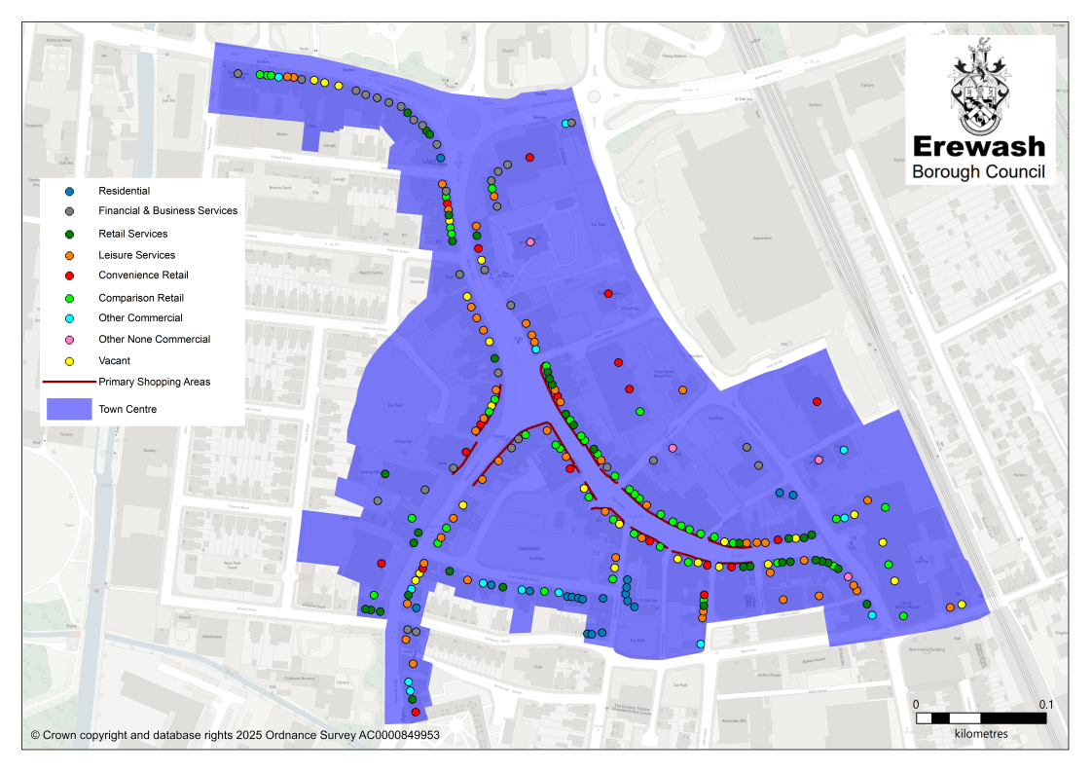

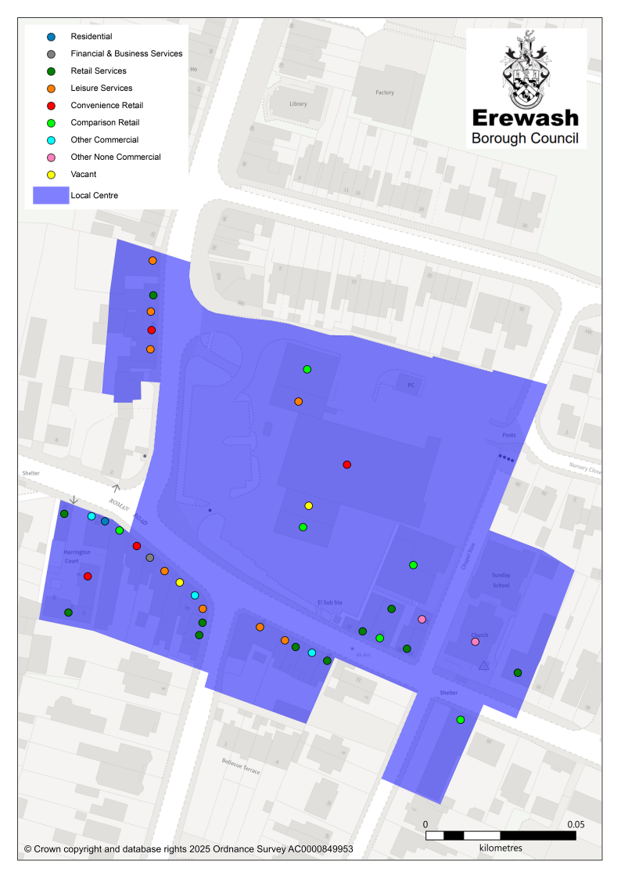

To see unannotated boundary maps in more detail please visit: <https://map.erewash.gov.uk/isharelive.web/myerewash.aspx> and select the Planning (Policy Data) category then tick the box next to Town and Local Centers.