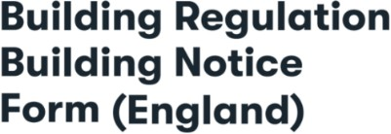 



**R13**



[buildingcontrol@erewash.gov.uk](mailto:buildingcontrol@erewash.gov.uk)

1. 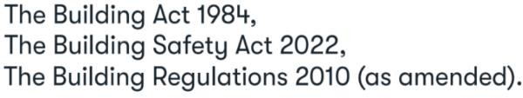Location of site to which the building work relates

Address (incl postcode)

1. **Applicant details (Property, Building or Land Owner)**

Title First Name Last Name Company Name (If Applicable)

Address (incl postcode)

Telephone Mobile

Email

1. **Agent details (where different from the applicant)**

Title First Name Last Name Company Name (If Applicable)

Address (incl postcode)

Telephone Mobile

Email

1. **Proposed works**

**Floor Area/ Value of works**

**1 of 3**

1. **Date of Commencement**



**R13**

1. **Intended use of the building**
2. **Person responsible for payment of fees**

Title First Name Last Name Company Name (If Applicable)

Address (incl postcode)

Telephone Mobile

Email

**Please Note - Application Fee Policy**

By completing and submitting this application form, the applicant and the person named as responsible for payment of fees acknowledge and accept that this is a formal application, not a general enquiry.

Applications are processed upon receipt, and an administrative fee of £126.00 is applicable, even if the application is later withdrawn after the statutory 14-day cancellation period.

If you are unsure or require clarification before submitting an application,

please contact us via email at [buildingcontrol@erewash.gov.uk](mailto:buildingcontrol@erewash.gov.uk)

By submitting this form, you confirm that you understand and agree to these terms.

**2 of 3**

**Declaration**



**R13**

This application is deposited in relation to the building work etc., as described above. It is submitted in accordance with [Regulation 12(2)(a)](https://www.legislation.gov.uk/uksi/2010/2214/regulation/12)

and is accompanied by the appropriate charge.

I / we apply for Building Notice Acceptance as described on this form and as detailed on any supplementary documents.

Signature

On behalf of

insert applicants name where the declaration is made by an agent

Date

The use of a building notice to inform the local authority of building work etc., is restricted to certain building types. Additional information will also be required to accompany your building notice depending upon the work proposed. Further information can be found in the attached notes and checklist. This form cannot be used for building control approval applications for higher-risk building work or stage of higher risk

building work or for work to existing higher-risk buildings. Applications for building work to higher-risk buildings can be made [here.](https://www.gov.uk/guidance/manage-a-building-control-application-for-a-higher-risk-building?utm_medium=email&utm_campaign=govuk-notifications-topic&utm_source=c6323063-0050-4c04-b498-92296e154abd&utm_content=immediately) Form created in May 2025.

**3 of 3**